1. Enclosure, Type EPH

These devices are enclosure for manual motor starter MMS-32H/HI.

1.1 General – Fig.1 represents the entire EPH Series

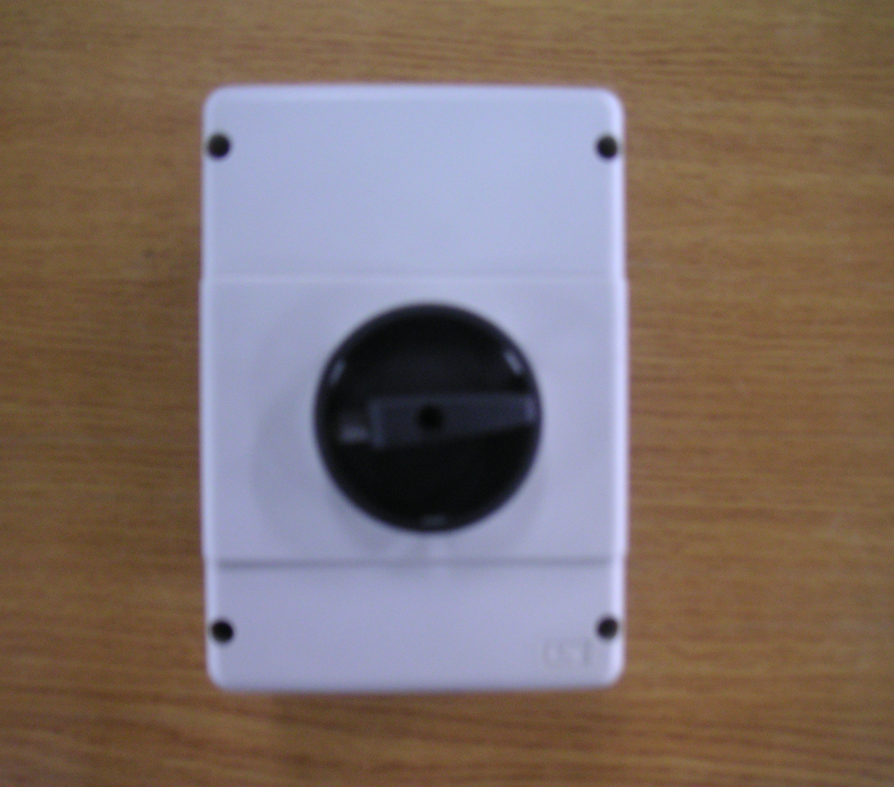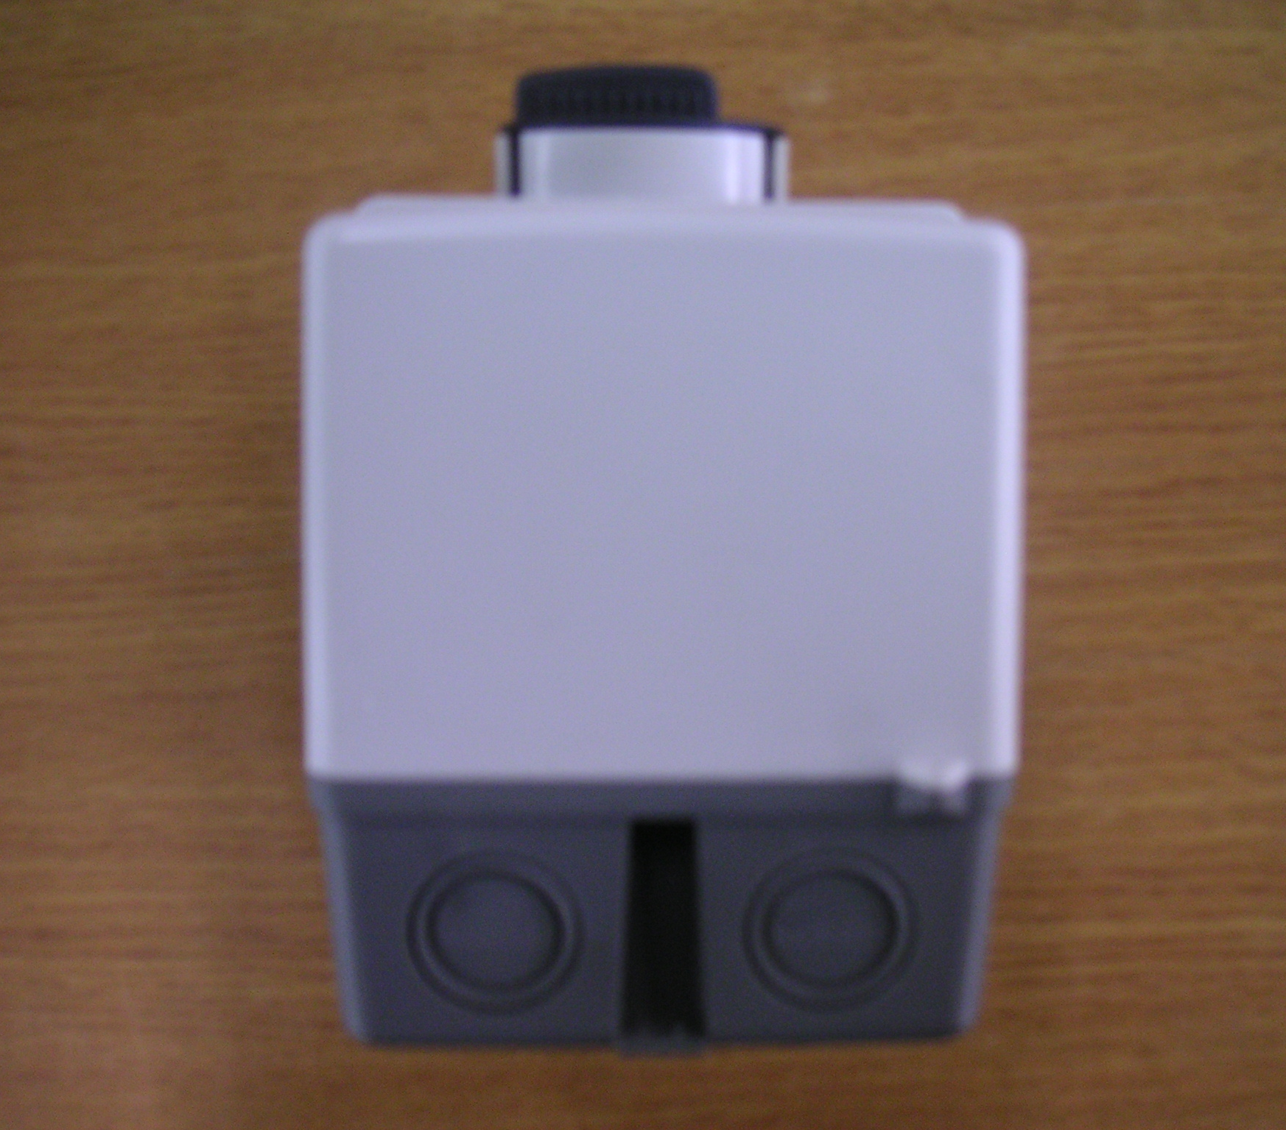

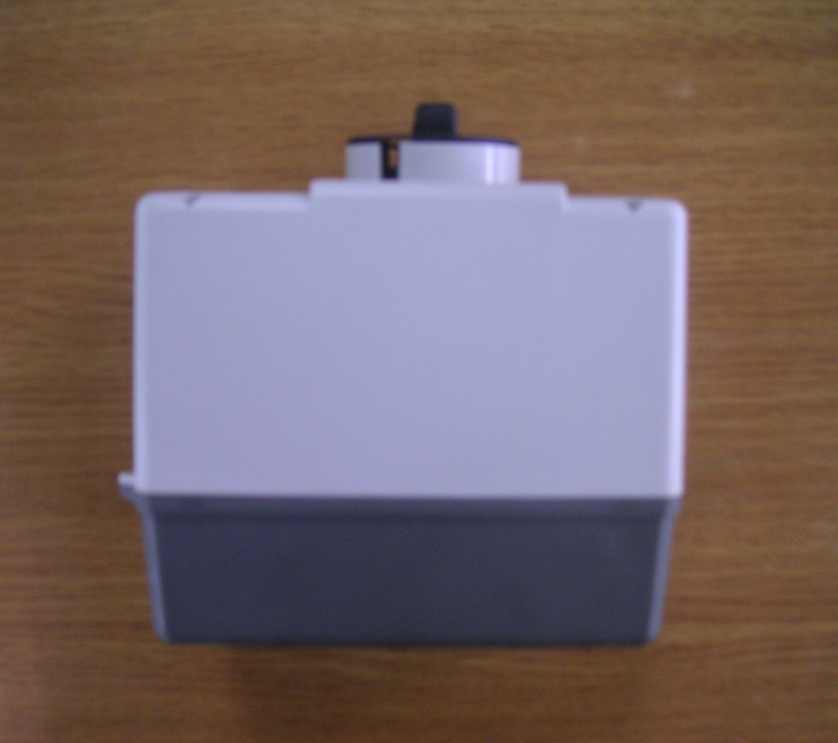

[Fig 1] EPH32-65S

1.2. Component : EPH32-65S
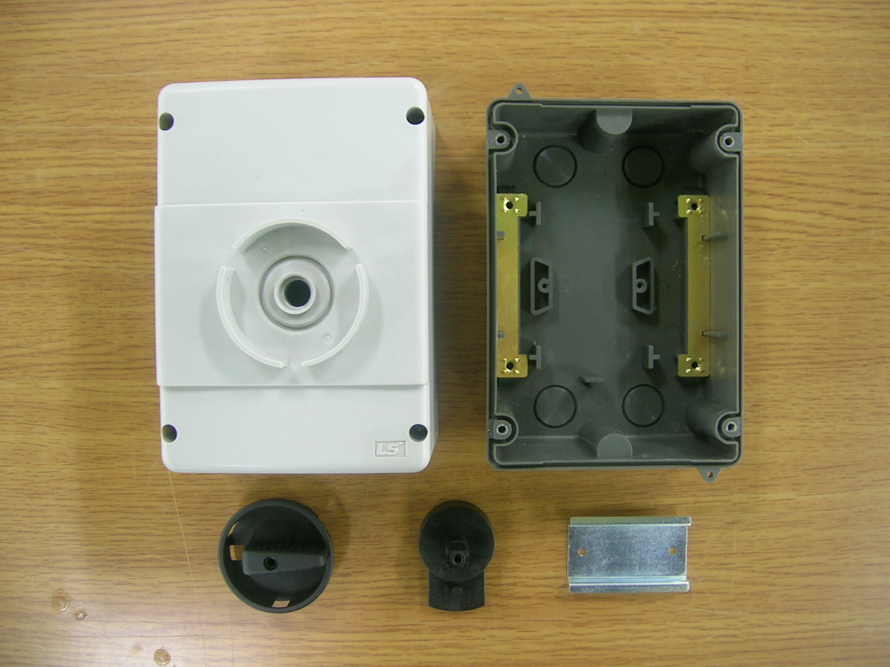
1
3
2
6
4
5
7
[Fig 2] EPH32-65S

Example

1.3 Construction details:

1.3.1 General - The details of construction are covered in fig. 2

1.3.2 Corrosion Protection - All parts of corrosion resistant materials or painted
or plated as corrosion protection.

1.3.3 Tolerances - Dimensions are nominal unless specified otherwise.

1.4 Nominal breakdown :

E
Material
Enclosure
P Plastic
M Metallic
P
H Handle
S Seesaw

H
Operating
MMS-32AF
MMS-63AF
100 MMS-100AF
32
Frame size
IP 65
65
IP grade
S Surface
F Flush
S
Mounting
-

1.5 Technical Data

Name
EPH32-65S
Type
Degree of protection
IP 65
Locking device
none
Motor starter size
MMS-32H/HI
Mounting
Surface
Material of insulation
ABS
Molded-Plastic enclosure with rotary operating mechanism

1.6 Demension

